# Welcome to Mighty Oak Acorn Workbook

## Overview

As part of CSE 170 Technical Teamwork, you will work in teams of 3-4 on four different Acorn projects. This workbook is to assist you in forming those projects.

## Purpose

The purpose of working on projects is to help you better understand the complexity and practicality of the elements you learned in class. You and your team create the projects through careful preparation, guidance by the Spirit, and teamwork using inspiration, collaboration, and innovation.

## Background

 Please read and watch the following information

* <https://www.byui.edu/president/past-presidents/jacob-spori>
* <https://www.byui.edu/devotionals/justin-hodges>

## Requirements

Each project will focus on the Influence model and the Institutional Learning Outcomes.

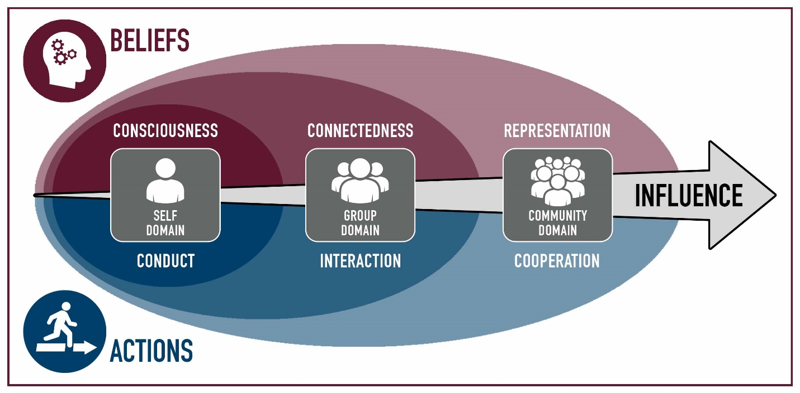

Each project will focus on the Self, the Group, or the Community. Tying in the Belief or Action attributes associated in the Model of Consciousness: Conduct, Connectedness, Interaction, Representation, and Cooperation.

The university has four Institutional Learning Outcomes.

Each of your Acorn Projects will be assigned one of these learning outcomes.

* A Disciple of Jesus Christ
  + We believe in Jesus Christ as the Son of God and strive to follow Him.
* Sound Thinkers
  + We frame and solve problems using creative and critical thinking.
* Effective Communicators
  + We develop and express ideas that are purposeful, organized, and clear
* 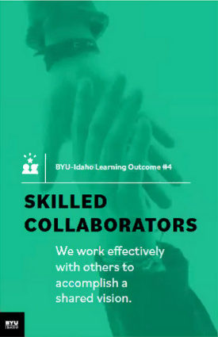****Skilled Collaborators
  + We work effectively with others to accomplish a shared vision.

**NOTE: All I.L.O.s need a project.**

# Four Project Breakdown:

A project will consist of the following parts

* List the values associated with the project & a statement of the project vision
* Describe each of your roles
* A statement of your vision of success
* Each project must be a minimum of 10-20 hours.
* The project will have a Specific, Measurable, Achievable, Realistic, Timely Goal.
* Definition of the Goal: Who, What, Where, When, How & Why
* List of Milestone, Achievements, Checkpoints, and Deliverables.

What should you do for your project? That is up to you and your team. You and your team will have to have some brainstorming ideas. Research some ideas, have backup ideas, and work together to synergize to come up with an innovative project.

## Types of Projects

Acorn projects are small; they are smaller than class projects and bigger than individual and team assignments. You work on the Acorn Projects as a team.

Examples of Acorn project:

Rules: You may use one of these examples as is. You may modify another. The other two you must come up with as a team.

* Attend a [Career Services](https://www.byui.edu/career/preparation) event as a team and work on a deliverable
* Participate in “[Get Involved](https://www.byui.edu/get-involved)”: Recreation, Ushering, Get Connected, I-Serve, Peer Mentoring, Rep Council, Tutoring
* Participate in a service project, service information, training that will help other students at BYU-Idaho.
* Create a program together, use a collaborative tool and resource repository.
* Join a Department Society and work together to contribute to a project
* Attend a Society Event such as a Hack-A-Thon, participate as a team
* Participate in a Sport, Sporting Event, or Team activity
* Attend a Leadership conference/activity produced by Student Services
* Participate in an Escape Room, Rope Course, or similar activity
* Discover 4+ campus building activities: for example Geology, Animal, Garden tour, Planetarium
* Plan three group date, with at least 3 activities
* Play 5 different players vs the board, 2-3 times, or an RPG game

# Participation

Each project should be a significant effort. It will require some brainstorming, planning, execution, and reflections.

Each project should for the team be about 10-20 hours cumulative, with multiple sessions. If there are four in a group, this breaks down to 2-4 hours each. I suspect that you will be around 3-5 hours each.

You work together as a team and do not split up the projects individually among yourselves.

# Brainstorming

The following are tools and concepts you should know about brainstorming and managing your team’s project and members. We will be covering each of these throughout the semester in detail and are here for reference and reminders.

* 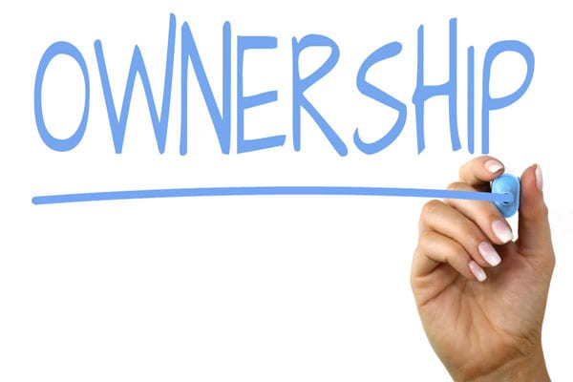Ownership
  + Ownership is one of the hardest things to learn. Ownership is taking the goal of the team and making it yours. It goes along with the scripture, “Be One.” You put your whole might, mind, heart, and soul into it.
* Listening
  + Listening is a key element in brainstorming. We have two ears and one mouth. For some reason, our ear does not hear when our mouth is moving and making sounds. Lord intended us to listen twice as much as we talk. If it became a problem, use the tool “the Talking stick,” which the person holding the stick gets to talk about, then pass it along.
  + “Seek first to understand, then to be understood” – Steven R. Covey
* Brainstorming
  + This process is where you through ideas on the wall and vote on them. It is best to come prepared with 4-5 ideas, accept other ideas, and be prepared to have your ideas merge with others to be better ideas.
  + A couple of questions to ask to help with the process
    - If you had unlimited finances, what would you do?
    - If you had magic, what would you do?
    - If you had unlimited time, what would you do?
* Problem Solving
  + We are problem solvers. For thousands of years, your ancestors solved problems. You can solve problems. The problem sometimes is making a choice and committing to it.
  + Steps: Describe the problem, gather information, determine important factors, visualize the solution, create action steps.
* Decision making
  + Do not get stuck in the analysis paralysis loop, which is thinking about a solution and not taking any action. Pick a solution and go with it. A boat never sails if it does not get in the water.
  + Sort, Rank, and Vote on the solution. And then do it. The change will happen along the way that will make it better.
* Conflict Management
  + 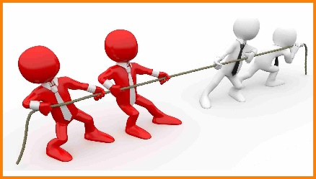 Everyone has different experiences and opinions based on those experiences. Everyone has different backgrounds and values-based on those backgrounds. That is ok and is necessary. Without conflict, a boat does not sail, and planes don’t fly. We do not strengthen our muscles, bones, and tendons. Good Conflict Management creates a space where ideas can share, discuss, analyze, poked at, torn apart, and put back together better, without insults, put-downs, or negative feels.
  + “You can empower yourself, but can only encourage others.”
  + Tools: Negotiate with rules and limits, be cooperative, be direct, be aware of yourself and others, establish trust, be open.
* Communication
  + Oh, communication. Say what you mean. Say what you are going to say, say it, and say what you said. Keeping your thoughts back does not work with brainstorming. Letting everyone participate is also just as important. Being present is also needful.
    - Form of Communication: Nonverbal, Oral, and Written
    - Blueprint of Communication: Message, Sender, and Receiver
    - Assure good communication: Common ground, Sincerity, Authority (to act, not be acted upon), and clarity.
    - Barriers of Communication: lack of receptiveness and a good environment.
* 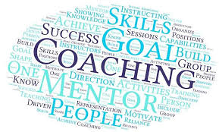Coaching and Mentoring
  + Ask for help is necessary. Ask to have some to report to also necessary. You don’t think you need a coach; you can do it on your own. Think again. Every professional has a coach; that is how they got to be a professional—sports, Business, C.E.O., etc.
* Change
  +  Things are going to change; plan on it. The first plan never works out. The original idea will not be the final product. Being adaptable is necessary. Ask a carpenter if every cut is exact or is just close enough. Ask an artist if all lines are straight. An Engineer is there no tolerances. Build in the wiggle room.
    - When change is needed, leading change can make it happen
    - How to lead change: recognize the change, empower others to make the change, base change on value, mission, and vision, establish urgency, move ahead with the unknowns (manage and mitigate the risks, don’t get stuck in analysis paralysis),
* 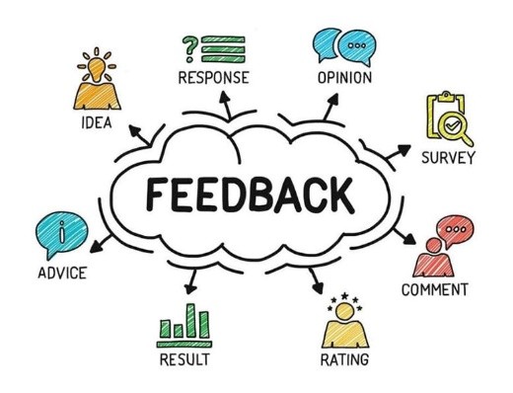Feedback
  + You are going to receive feedback. Prepare for it. That is how you learn. Make sure you go in without your eye wide shut, seeing but not seeing. Other perspectives allow you to see what you forgot you saw. Remember, the feedback is not you. It is reality. It is you being looked at through someone else’s eyes and mind, repeated back to you through your eyes and mind. It is like taking a photograph, making a drawing of it, and then you are describing what you saw from the drawing. Receiving feedback is like receiving the word at the end of the play, the game Telestrations.
  + “Consider feedback to be a gift. It truly is.”

# Acorn Project Worksheet Explanation

Record the summary of your brainstorming activities.

## Project Influence

Pick one of the following:

* Self
  + oBelief: Consciousness
  + oActions: Conduct
* Group
  + oBelief: Connectedness
  + oAction: Interaction
* Community
  + oBelief: Representation
  + oAction: Cooperation

Explain how this project will Influence you, your team/group, or the community.

## Project Mission Focus:

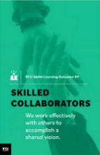Identify 1 of the following for this Project Goal. Must have one project goal for each I.L.O.

* 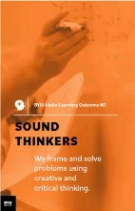oDisciple of Jesus Christ
* oSound Thinkers
* oEffective Communicators
* oSkilled Collaborators

## Personal Values

Values are our core beliefs or desires that guide or motivate our attitudes and actions. List your values and the forms that they take; principles, standards, personal qualities, character traits, or ethics codes.

## Vision Statement

A vision is a picture of future success. Our vision is when we think far enough to realize that there will be challenges for which we can prepare.

## S.M.A.R.T. Goals

*“A Goal Without a Deadline is Only a Dream!”*

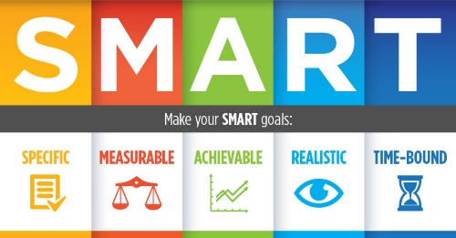Define your Acorn project as a “SMART” (**S**pecific, **M**easurable, **A**ttainable, **R**elevant, and **T**imely) goal.

* **Specific** - Describe this Acorn Project Goal in enough detail so that you, your teammates, and the instructor know specifically what you are going to do, how it is important, or how it will impact you. Is it challenging?
* **Measurable** - Describe how this Acorn Project Goal is Measurable**.** How will you know when the goal is completed? What is your exit strategy? What are the milestones?
* **Attainable** - Describe how this Acorn Project Goal is Attainable**.** Can it be accomplished? You have 10-12 weeks to complete the project with four people.
* **Relevant** – Describe how this Acorn Project Goal is Relevant. How does it relate to BYU-Idaho I.L.O.s? How will it help grow your Acorn into a might oak?
* **Timely** - Describe how this Acorn Project Goal is Timely**.** Can it be accomplished in a reasonable amount of time? Ten cumulative hrs. minimum per project

Re-write the SMART goal as a single sentence.

## Milestones

It takes more than one step to complete goals. List up to 10-12 milestones, achievements, checkpoints, or deliverables for your goal. Following the network of high-level objectives, break down each objective into separate activities necessary to accomplish it. Order and prioritize the activities by the longest and plan.

# Approval of Project

You will submit your projects for review & approval to your instructor. Expect a week for feedback. You can continue as if it was approved; meanwhile, your instructor will give you additional tasks and ideas to improve the projects. Submit a final revision with changes for approval.

# Update Software Concept. Upgrade System Icon. Application Status.. Royalty Free Cliparts, Vectors, And Stock Illustration. Image 126610927.Bi-Weekly Status of Project

As mentioned in the brainstorming, you will have changes, conflicts, decision making. Change is normal. Each week you need to meet with your team to discuss the progress of your Acorn Projects. You can complete them in sequence or parallel.

You will be required to provide the status of your Acorn projects every other week. You will need to indicate the **percentage done**.

# Stages of Team Development

As you move with your Acorn project, you and your team will hit some challenges and accomplish some breakthroughs. Here is a guide to let you know what you will face as your team pulls together. It is expected that each goal has multiple sessions/milestones, to show these phases.

The first stage in a team’s development is **Forming** (“Pickup Sticks,” “Polite”).

Most team members are eager to be on the team. However, they often come with high, unrealistic expectations. These expectations come with some anxiety about how they will fit in, how much they can trust others, and how much time to set aside. Team members are also unclear about norms, roles, goals, and timelines. In this stage, there is a high dependence on the leading figure for purpose and direction. Behavior is usually tentative and polite. The major issues are personal well-being, acceptance, and trust.



The second stage in a team’s development is **Storming** (“At Odds,” “Testing”).

As the team gets some experience working together under their belt, there is a dip in morale as team members experience discrepancies between their initial expectations and reality. The difficulties in accomplishing the task and working together lead to confusion and frustration, and growing dissatisfaction. Negative reactions to each other develop, and subgroups form, which polarize the team. The breakdown of communication and the inability to problem-solve result in lowered trust. The primary issues in this stage concern power. Control and conflict.

The third stage in a team’s development is **Norming** (“Coming Around,” “Valuing”).

As the issues encountered in the second stage are addressed and resolved, morale begins to rise. Task accomplishment and technical skills increase, contributing to a positive, even euphoric feeling—clarity and commitment increase on purpose, values, norms, roles, and goals. Trust and cohesion grow as communication becomes more open and task-oriented. There is a willingness to share responsibility and control. Team members value the differences among themselves. The team starts thinking in terms of “we” rather than “1.1! Because the newly developed feelings of trust and cohesion are fragile, team members avoid conflict for fear of losing the positive climate. This reluctance to deal with conflict can slow progress and lead to less effective decisions. Issues at this stage concern the sharing of control and avoidance of conflict.

The fourth stage in a team’s development is **Performing** (“As One,” “Trusting”).

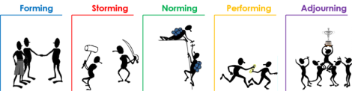At this stage, both productivity and morale are high, and they reinforce one another. There is a sense of pride and excitement in being part of a high-performing team. The primary focus is on performance. The purpose of roles and goals are clear. Standards are high, and there is a commitment to meeting standards and continuous improvement. Team members are confident in their ability to perform and overcome obstacles. They are proud of their work and enjoy working together. Communication is open, and leadership is shared. Mutual respect and trust are the norms. Issues include continued refinements and growth.

## Pushing Through

As mentioned in the brainstorming, you will have changes, conflicts, decision-making. Each week you need to meet with your team to discuss the progress of your Acorn Projects. You can complete them in sequence or parallel.

You will be required to provide the status of your Acorn projects every other week. You will need to indicate the **percentage done**.

## The finish line

No runner stops exactly at the finish line; No athlete walks straight to the car and goes home; No engineer throws away all the equipment after an experiment. After camping, what do you keep and what do you throw away. There is clean up, reflection, lessons learned, and preparing to do it again.

You will need to complete the following for each Acorn:

1. Presentation
   1. Your team will be required to present a 3-5 minute briefing of your Acorn Project to the class.
2. Lessons Learned
   1. You need to reflect on the vision and goal of the project. Think if you were to do each of the projects again, how would you do better. What advice would you give someone?
   2. You need to have at least two lessons learned for each of the 4 Acorn Projects.
   3. Also, additional lesson learned on your team dynamics.
3. S.T.A.R
   1. Write up a summary of your experience in the following format
      1. 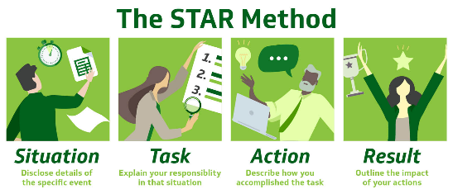S. Situation
      2. T. Task
      3. A. Achievement
      4. R. Results
4. Participation
   1. Each of you will provide a report on how you participated and
   2. Each of you will report on how each member of the team participated.
   3. As a team, you will determine how many hours you spend on each project.
5. Stop, Start, and Continue
   1. As a team and as an individual, you need to reflect on three things:
      * Stop: List an item that your team and yourself that you need to stop doing that hindered the team and project.
      * Start: List an item that would improve and innovate the project.
      * Continue: List items that went well and is necessary for the success of the project
   * Complete Stop, Start, and Continue for each of your projects.

# Presentation of Acorns Ceremony

On the Last of Class, we will have a ceremony where I will present you with four Acorns, one for each project that you completed.



## Other Resources

* <https://www.byui.edu/mighty-oaks>

**Acorn Project Worksheet**

**Project Mission Focus:** Disciple of Jesus Christ

* **Team Name:** TeamAte
* **Team member’s Names:** Aaron Tumbokon, Jose Hernandez, Juan Zurita, Kason Bray Mills
* 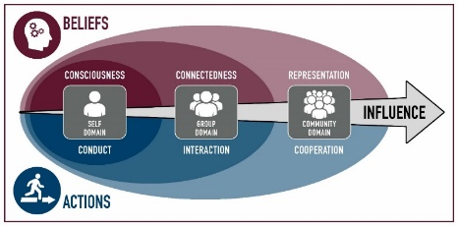**Project Title:** Watch Sunday Devotional with Elder Bednar
* **Project Influences:**

|  |  |  |
| --- | --- | --- |
|  | **Belief** | **Actions** |
| **Self** | ýConsciousness | ýConduct |
| **Group** | ýConnectedness | ýInteraction |
| **Community** | oRepresentation | oCooperation |

**Explain:** As we learn from an Apostle of Christ, we will gain consciousness and conduct principles that will guide us in our life. Also, we will share our learnings that we felt through the Holy Ghost and will accomplish connectedness and interaction.

* **Project Values:** Increase of Faith and Testimony.
* **Description:** We will watch the Sunday devotional with Elder Bednar and we will write down all the feelings we had while watching it. Then, we will group together to discuss and share what we have learnt.
* **Vision Statement:** Apply the principles and spiritual knowledge we learn in our life.
* **SMART Goal:** Being better disciples of Christ
  + Specific: Strive to become better disciples of Christ by increasing our faith, testimony and **habits**
  + Measurable: Be aware of the **times** we pray, read our scriptures and seek for God’s guide.
  + Attainable: By reaching our personal goal for the times we read and pray we will attain it.
  + Relevant: We will develop our testimony and spiritual well-being
  + Timely: We are going to evaluate ourselves in 6 weeks to see if we reached the goal of being better disciples of Christ

***Summary***: Strive to have better habits that will help us to be better disciples of Christ by increasing the time we spend reading, praying and seeking for God’s guide as we measure the amount of time, we finally give to it.

* **Audience (*Who, What, Where, When, Why, How*):**

Us, our families, friends and the people surrounding us. By striving to become closer to Christ we will change and people in our surroundings will notice that. We hope that they see our change and they want to come closer to Christ too.

* **Roles and Responsibilities:**

**Role Responsibilities**

* + **1: Juan Zurita Check up on Kason**
  + **2: Kason Mills Check up on Aaron**
  + **3: Aaron Tumbokon Check up on Jose**
  + **4: Jose Hernandez Check up on Juan**
* **Milestones**
  + 1. Watch devotional
  + 2. Get together to talk about the devotional
  + 3. 1st check of goals
  + 4. 2nd check of goals
  + 5. 3rd check of goals
* **Instructor Improvements Suggestions**:
  + _________________________________________________________
  + __________________________________________________________

[ ] **Approved** Date: __________________

**Acorn Project Worksheet**

**Project Mission Focus:** Sound Thinkers

* **Team Name:** TeamAte
* **Team member’s Names:** Aaron Tumbokon, Jose Hernandez, Juan Zurita, Kason Bray Mills
* **Project Title:** Dungeons and Dragons
* **Project Influences:**

|  |  |  |
| --- | --- | --- |
|  | **Belief** | **Actions** |
| **Self** | ýConsciousness | ýConduct |
| **Group** | ýConnectedness | ýInteraction |
| **Community** | ýRepresentation | ýCooperation |

**Explain:** The game Dungeons and Dragons affects all aspects of influence. From character creation to fighting the monsters and solving the game itself.

* **Project Values:** Have fun and finish the game as a team
* **Description:** There are a lot of options when it comes to playing dungeons and dragons. Having ideas and imagination as a team will be the goal of this project
* **Vision Statement:** Solve a Dungeons and Dragons game as a team where our imagination is the limit.



* **SMART Goal:**
  + Specific: To solve a Dungeons and Dragons game
  + Measurable: Milestone is every save point, and the goal is reached when we solve the game.
  + Attainable: Yes, it is attainable. We have about 6 weeks to go so we would be able to reach it.
  + Relevant: It will help us know each other more
  + Timely: In about 6 weeks

***Summary***: Our project is to have 1 game of Dungeons and Dragons where our milestone will be every save point of the game. Our goal is to solve the game as a team within 6 weeks.

* **Audience (*Who, What, Where, When, Why, How*):**

Our teammates and the people we play dungeons and dragon with at the game store possible in the afternoon

* **Roles and Responsibilities:**

**Role Responsibilities**

* + **1: Player 1** **Creating a character and following their role**
  + **2: Player 2** **Creating a character and following their role**
  + **3: Player 3** **Creating a character and following their role**
  + **N: Player 4** **Creating a character and following their role**
* **Milestones**
  + 1. Make a character
  + 2. Survive save point
  + 3. Survive save point
  + 4. Survive save point
  + 5. Finish the game
* **Instructor Improvements Suggestions**:
  + _________________________________________________________
  + __________________________________________________________

[ ] **Approved** Date: __________________

**Acorn Project Worksheet**

**Project Mission Focus:** Effective Communicator

* **Team Name:** TeamAte
* **Team member’s Names:** Aaron Tumbokon, Jose Hernandez, Juan Zurita, Kason Bray Mills
* **Project Title:** Soccer
* **Project Influences:**

|  |  |  |
| --- | --- | --- |
|  | **Belief** | **Actions** |
| **Self** | oConsciousness | oConduct |
| **Group** | oConnectedness | oInteraction |
| **Community** | oRepresentation | oCooperation |

**Explain: Soccer is a sport that requires effective communication because of the how the**   **sport is played.**

* **Project Values: Have a fun time and learn how to communicate with each other.**
* **Description: There are plenty of communication skills required in soccer.**

**Vision statement: Apply what learn playing soccer as a team.**

* + Specific: Working on the communication skills we get from this project
  + Measurable: Become better listeners in our friendships and relationships
  + Attainable: Become better listeners in our friendships and relationships
  + Relevant: We will develop better communication skills, while working on those skills
  + Timely: We are going to reach out to each other to see how we are doing with our communication skills.

***Summary***:

**will be able to see the difference in our communication skills because we will be able apply what we learn in this project. We plan to us the communication skills we have now, but as time goes by our skills will grow.**

* **Audience (*Who, What, Where, When, Why, How*):**

**Us, family, Friends we difference in the communications skills we have because as time goes by our skills will become better as we apply them on a daily basis.**

* **Roles and Responsibilities:**

**Role Responsibilities**

* + **1:Jose Hernandez** **jose will check up on Aaron**
  + **2:Juan Zurita**  **Aaron will check up on Jose**
  + **3:Aaron Tambokon** **Juan Zurita will check up on Kason**
  + **4. Kason Mills** **Kason will check up on Juan**
* **Milestones**
  + 1. Set a day to play soccer
  + 2.Learn how to play soccer
  + 3.Learn the rules of the sport
  + 4. Apply communication skills
  + 5. Have fun while palting soccer
* **Instructor Improvements Suggestions**:
  + _________________________________________________________
  + __________________________________________________________

[ ] **Approved** Date: __________________

**Acorn Project Worksheet**

**Project Mission Focus:** Skill Collaborators

* **Team Name:** TeamAte
* **Team member’s Names:** Aaron Tumbokon, Jose Hernandez, Juan Zurita, Kason Bray Mills
* **Project Title:** Escape room
* **Project Influences:**

|  |  |  |
| --- | --- | --- |
|  | **Belief** | **Actions** |
| **Self** | ýConsciousness | ýConduct |
| **Group** | ýConnectedness | ýInteraction |
| **Community** | oRepresentation | ýCooperation |

**Explain:** An escape room game will need us to develop consciousness, manage our self-conduct, connect as a group, interact with everybody and cooperate.

* **Project Values:** Communication, problem solving, planning, dealing with pressure
* **Description:** We will gather to play an escape room game and set goals to finish the game the fastest way possible.
* **Vision Statement:** We will gain good skills that will help us to have a great set of problem-solving skills. We will learn how to work efficiently in a team and manage our tasks
* **SMART Goal:**
  + Specific: End the Escape Room as fast as we can
  + Measurable: We will measure the time we spend planning, assigning tasks and completing the tasks
  + Attainable: We will check the time we have done and give feedback on how we did it.
  + Relevant: This game will help us to work as a team under pressure and will help us develop a problem-solving ability
  + Timely: We will compare the time we did in solving the game with the time that other teams that have made it too.

***Summary***: The goal is to finish the game in the fastest way we can and give feedback on how we did and how we could have done better. This will help us to do better next time.

* **Audience (*Who, What, Where, When, Why, How*):**

We are the audience. We will play an scape room game in some weeks and this will help us to accomplish this project.

* **Roles and Responsibilities:**

**Role Responsibilities**

* + **1:** **Player 1**-**Leader** **Plan, assign tasks and perform tasks**
  + **2: Player 2 Plan and perform tasks**
  + **3: Player 3 Plan and perform tasks**
  + **4: Player 4 Plan and perform tasks**
* **Milestones**
  + 1. Gather to an escape room place
  + 2. Plan the game we are going to play
  + 3. Assign tasks and think how we can accomplish them
  + 4. Complete tasks and win the game
  + 5. Have feedback on how we performed
* **Instructor Improvements Suggestions**:
  + _________________________________________________________
  + __________________________________________________________

[ ] **Approved** Date: __________________